# CS 255 System Design Document

## UML Diagrams

### UML Use Case Diagram

### UML Activity Diagrams

Use Case 1: Scheduling a Driving Test.

Use Case 2: Viewing Test Results.

### UML Sequence Diagram

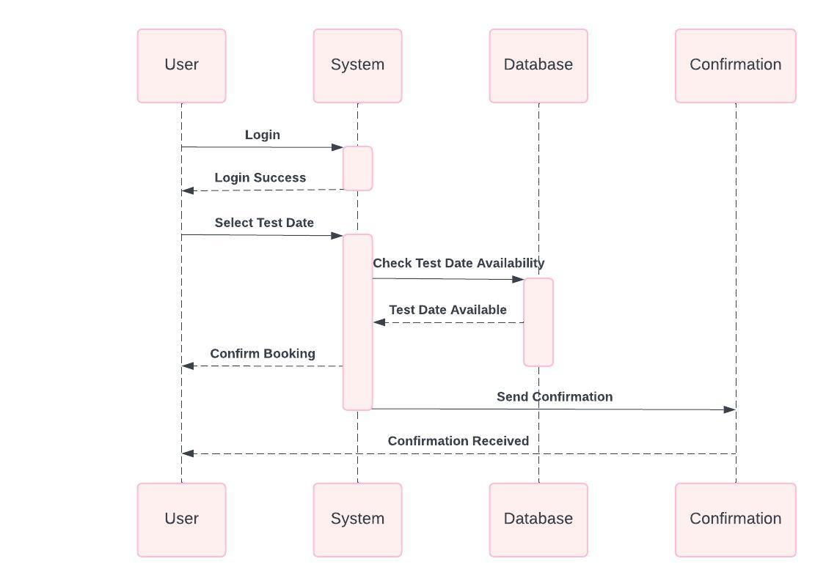

### UML Class Diagram

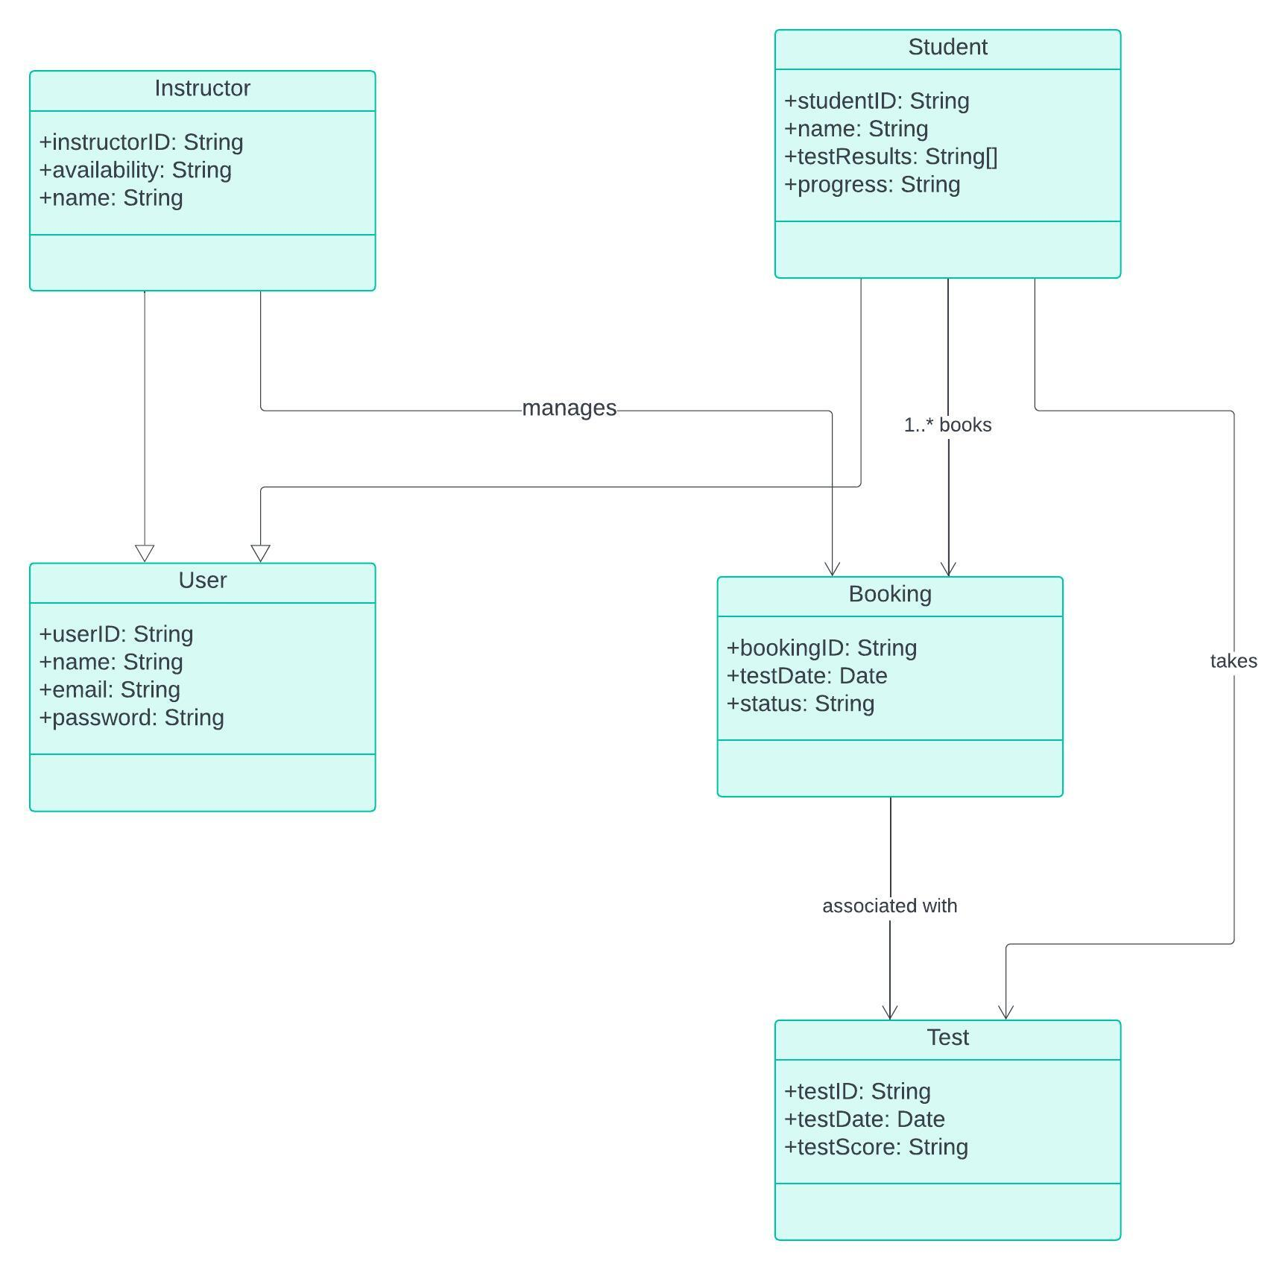

## Technical Requirements

The DriverPass computer-based system will require quite robust hardware, software, and infrastructure. Major hardware required includes application and database servers, with client devices along the lines of computers and mobile devices. Software entails an operating system such as Linux or Windows Server, web servers like Apache, in addition to a database management system like MySQL or PostgreSQL. Java or Python will be used in conjunction with the backend, while HTML/CSS with JavaScript will be for the frontend. Development and testing tools such as Git and Selenium ensure smooth coding and deployment processes. The system also needs to have safe networking through firewalls and SSL certificates for encrypted communication, and scalability or storage using AWS or Azure cloud services. This is complemented with regular backups and disaster recovery plans. This layer of hardware, software, and infrastructure ensures reliability, scalability, and security of the DriverPass system for its users.